SHOPNEST STORE : Report on Sales and Revenue Analysis

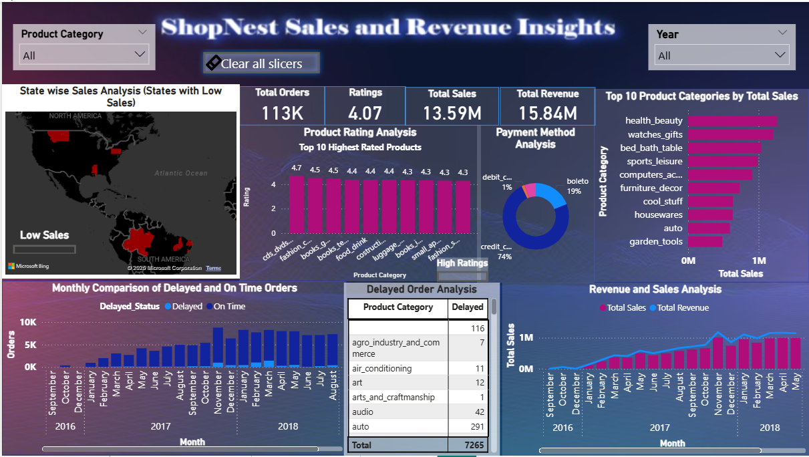

Drill through Cross Report Feature providing a detailed analysis of late and on time deliveries

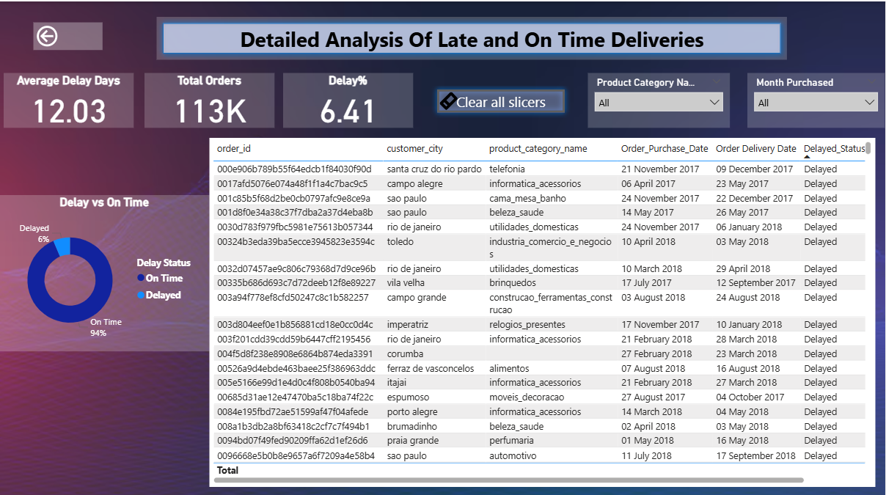

 | Question Statement:  Top Categories by Total Price: Identify and visually represent the top 10 product categories by total sales.  Explanation: Top category Health and Beauty indicate high sales and strong customer demand. Watches, gifts, bed bath table categories also show significant sale. Sports & Leisure and Computers & Accessories show consistent but slightly lower sales compared to the top three. Categories like Furniture & Décor and Cool Stuff generate moderate sales. Housewares, Auto and Garden Tools indicate lesser customer focus.  Top 3 categories contribute maximum sales, promoting business strategies. Bottom 3 categories indicate lesser sales as compared to other categories, so they need to be focused by marketing campaigns, seasonal discounts to increase sales. | Visualization:  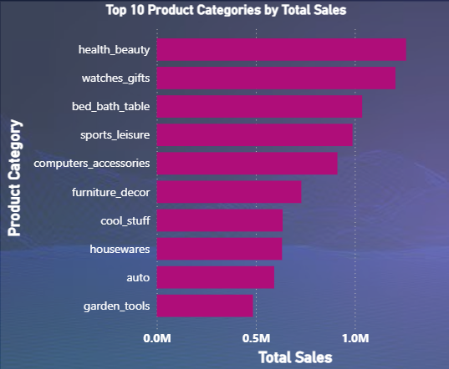
2. | - Question Statement:  Delayed Orders Analysis: Determine the number of Delayed Orders in each Category  Explanation: Bed, Bath, Table (770 delays) and Health & Beauty (717 delays) are the top two categories with the most delays. Together, they account for about 20% of all delays (1,487 out of 7,265). Office Furniture (133 delays), Stationery (167 delays), and Electronics (207 delays) have comparatively fewer issues. | Visualization:  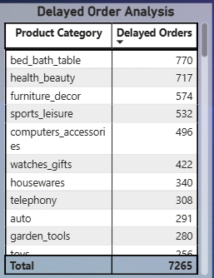
3. | - Question Statement:  Monthly Comparison of Delayed and On-Time Orders:  Create a dynamic visual that compares the number of delayed orders to the number of orders received earlier for each month. Utilize the drill through cross-report feature to provide a detailed analysis of late and on-time deliveries.  Explanation: There is a steady increase in total orders from late 2016 to early 2018, peaking around November 2017 to March 2018. Delayed orders (light blue) remain relatively low compared to on-time orders throughout the period. The majority of orders are delivered on time with delay% of 6.41% . The average days an order is delayed is 12 days. Highest order activity is seen during holiday and year-end months (Nov–Feb), indicating possible seasonal demand spikes and provided discounts. | Visualization:  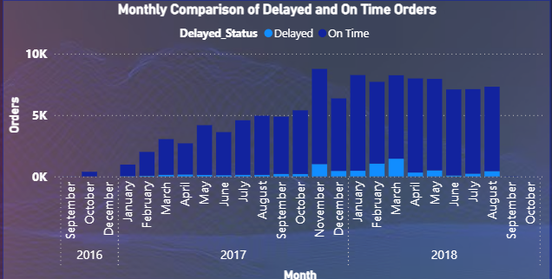  Drill through cross-report feature Detailed analysis of late and on-time deliveries.
4. | - Question Statement:  Payment Method Analysis: Analyze the most frequently used payment methods by customers using a visually appealing representation, such as a pie chart or other suitable visuals.  Explanation: Credit card accounts for 74% of total payments, indicating it is the preferred choice among customers.Boleto represents 19%, showing moderate usage as an alternative payment method.Debit card and usage of other modes is negligible at 1%, suggesting low adoption for these payment mode.  The market is heavily skewed towards credit card transactions, with very limited diversification in payment options. | Visualization:  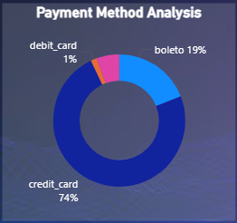
5. | - Question Statement:  Product Rating Analysis: Determine the top 10 highest-rated product and bottom 10 lowest -rated products using a bar or column chart.  Explanation: CDs, DVDs lead with a 4.7 rating, followed by fashion and books categories (4.5–4.4 range). All top products have ratings above 4.3, indicating high customer satisfaction. Books and fashion-related products appear multiple times among top-rated items. Security products are rated the lowest at 2.5, significantly below average. Categories like office furniture, home care, diapers, and audio have ratings between 3.6–3.8, indicating room for improvement. Bottom 10 lowest rated products need to enhance product quality, improve durability & design. | Visualization:  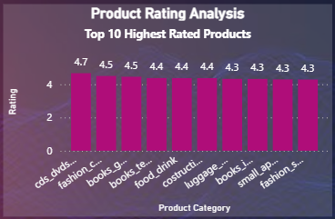  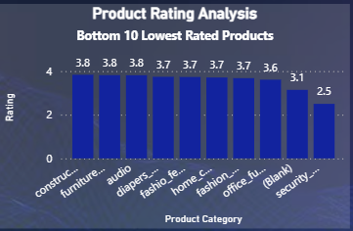
6. | - Question Statement:  State-wise Sales Analysis: Identify and visually represent states with high and low sales, providing a clear understanding of regional sales performance.  Explanation: Several regions in North America and South America exhibit low sales. Concentration of underperformance is notable in central and northern US states and a few South American regions. High sales are concentrated in limited regions, primarily in eastern South America and a few locations in North America. The geographical distribution shows uneven market penetration, with only a few states achieving strong sales. Sales performance is highly region-specific: A few states dominate high sales while multiple states remain underperforming. Indicates potential market expansion opportunities in low-performing regions. | Visualization:  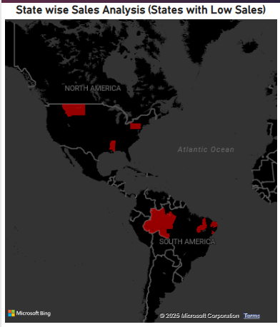  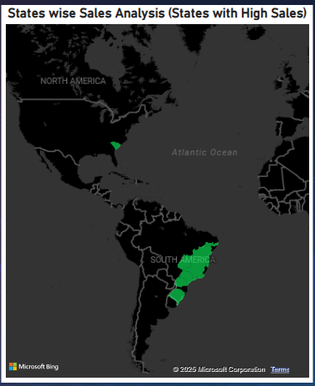
7.  8. | - Question Statement:  Seasonal Sales Patterns: Investigate and visualize any seasonal patterns (Quarterly) or trends in sales over the course of the year.  - Question Statement:  Revenue Analysis: Determine the total revenue generated by ShopNest Store and analyze how it changes over time(Yearly). Represent this information through suitable visuals to highlight trends and patterns.  Explanation:  Overall Trend  Steady growth in sales and revenue from late 2016 through mid-2017. By Q4 2017, both revenue and sales reached their peak. In 2018, performance remained high but showed signs of leveling off, with some fluctuations.  Seasonal / Quarterly Patterns  Q4 Peaks (Oct–Dec):  Noticeable spike in both revenue and sales, especially in Oct–Nov 2017 and again in late 2018.  Likely linked to holiday/seasonal demand (e.g., festivals, holiday shopping).  Q1 Stability (Jan–Mar):  Sales remain relatively high, but revenue shows dips after the Q4 peaks. Suggests promotions or discounts driving volume but lowering revenue per unit.  Q2–Q3 Plateau (Apr–Sep):  Sales are fairly steady (slight decline mid-2018). Revenue fluctuates but doesn’t grow as strongly, showing potential seasonality slowdown.  Key Findings  Growth phase: 2016–2017 saw rapid expansion in both sales and revenue.  Seasonal effect: Strong Q4 surges highlight the impact of festive/holiday periods.  Conclusion: Sales and revenue follow a clear seasonal cycle, with Q4 consistently outperforming other quarters. Businesses could capitalize on this by aligning marketing, inventory, and promotions ahead of Q4 while finding ways to stabilize revenue in Q2–Q3. | Visualization:  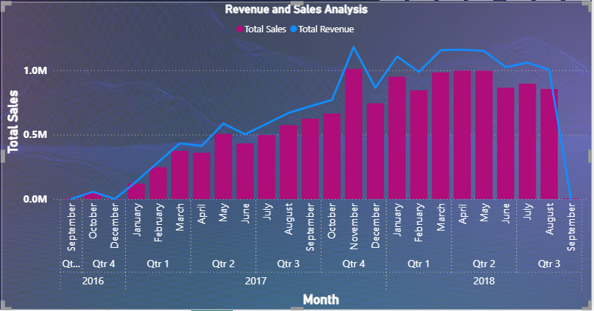
7.  8. |  | Visualization:

